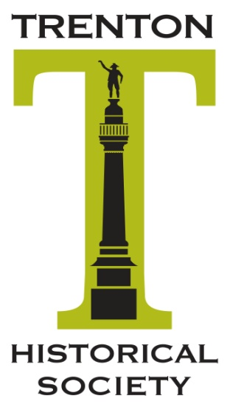
Trenton Historical Society
P.O. Box 1112
Trenton, NJ 08606
society@trentonhistory.org
(609) 396-4478

Damon Tvaryanas, President
Karl Flesch, Vice President
Sally Lane, Secretary
Elizabeth Yull, Treasurer

“We’re using our past to build our future.”

Did you know that Abraham Lincoln and the Beatles share a connection to our fair city? Both came through Trenton by train: President-elect Lincoln in February, 1861 where he delivered a rousing speech for a strong Union to the New Jersey Legislature; and the Beatles in February, 1964, fresh from their historic Ed Sullivan performance in New York. With their plane snowbound at Kennedy, they took the train through Trenton enroute to their next concert date in Washington, D.C.

Want to know more? Then check out the Trenton Historical Society at: https://trentonhistory.org/.Or
plan to come to our Annual Meeting with light hors d oeuvres June 23, 2024, at 2 o’clock at Cooper’s Riverview. The program features a panel discussion on the challenges and planned events for the upcoming 250th anniversary of the American Revolution. (Cost: $50/ per person)

The Trenton Historical Society (THS) turned 100 in 2019. But we’re not just an organization with a past. Here are a few of our more recent accomplishments:

- Our Restore Trenton! program has awarded nearly a quarter of a million dollars in grants assisting residential property owners with exterior restoration while encouraging historically appropriate home improvements. Annually, a Stop the Wrecking Ball fundraiser is held at notable city buildings to raise funds for the program. The 2023 fete, well-attended by patrons and corporate community sponsors, showcased Trenton’s beautiful marble City Hall.

- THS is a supporter of Trenton’s week-long history festival, Patriots Week. This past year, we brought in Penn State’s Dr. Friederike Baer, author of Hessians, German Soldiers in the American Revolutionary War. In February, THS co-sponsored Four Centuries of African American Soldiers, as part of an annual living history program at the Old Barracks Museum. In April, we hosted a Hungarian scholar, Dr. Eva Lovra, author of a study of Victor Bohm, Trenton’s modernist architect of the 1940s and 1950s.

- THS spearheaded the restoration of the Shaky Bridge, as a memorial to Jerry Harcar, the city’s longtime preservation officer and our fellow board member.

- THS also provide guided tours, and annually produce a calendar showcasing vintage pictures of Trenton locations.

Trenton Historical Society Board

Trenton Historical Society
P.O. Box 1112
Trenton, NJ 08606
society@trentonhistory.org
(609) 396-4478

Damon Tvaryanas, President
Karl Flesch, Vice President
Sally Lane, Secretary
Elizabeth Yull, Treasurer

“We’re using our past to build our future.”

At a Crossroad Between the Past and the Future

We are sending you this announcement because you have shown an interest in Trenton and the surrounding community. We could use your help. Send us your ideas and suggestions. Fill out this form on-line or mail it in. What would you like to see happening in the Capital City in the future? What programs and events, cultural or historic, would you and your family be interested in attending?
_____________________________________________________________________________
_____________________________________________________________________________
_____________________________________________________________________________

Become a Trenton Historical Society Member ($35 annual dues)
Name and contact info here: ______________________________________________________

Have a special skill or knowledge? Tell us what it is____________________________________

Sign on to assist one of our committees:

____ Artifacts Committee

____ Education Committee

____ Nominating Committee

____ Preservation Committee

Recommend someone you know to serve on our working Board Of Trustees
Name and Contact Information ___________________________________________________

Honoring the Past, Educating the Present, Preparing the Future

With gratitude and appreciation,

The Trenton Historical Society May 2024 v.4

